Law Enforcement I
Course Syllabus 2022-2023

School: Rivera Early College High School-6955 FM 802 Tel. #831-8700

Teacher: Mrs. Anna B. Gaucin Email: anaguilar@bisd.us

Conference: 5th Period-12:05pm-12:50pm Telephone: (956) 698-1842

Curriculum: iCEV

Prerequisites: Successful completion of Principles of Law, Public Safety, Corrections, and Security.

Course Description: Law Enforcement 1 is an overview of the history, organization, and functions of local, state, and federal law enforcement. This course includes the roles of constitutional law, the United States legal system, criminal law, law enforcement terminology, and the classification and elements of crime. You will be involved in role-play, public speaking and various hands on activities, 100% participation is expected.

NOTIFICATION: This course will expose the student to real-life situations and/or scenarios that may or may not include graphic photos, videos, language or other adult career specific information and situations. Students are required to participate group assignments, read aloud and present assignments occasionally.
Classroom Guidelines
Attendance: Students are expected to attend class everyday unless it is an excused absence. Students who miss class without permission are truant. Truancy is an unexcused absence and repeated truancy may be cause for disciplinary and/or legal action against the student and the student’s parent/guardian.

No Credit: Any student with less than 90% attendance will not receive credit for the course. It is the student’s responsibility to apply for credit.

Tardies: Please come to class on time. There is a ZERO tolerance on tardies; the appropriate disciplinary action will be taken:
1st offense: You will receive one verbal warning.
2nd offense: Your parents will then be notified

Make-up Work: Makeup work is the student’s responsibility. The student needs to ask the teacher for any missed work. A 3 day time limit will be given to make up missed work for an excused absence. Always ask for what you missed if you were out!

Late Work: The best way to be successful in this class is to do ALL assignments and turn them in on time. Late work will have points deducted as follows:
- 10 points deducted for each day assignments late (Max 3 days – 30 points).
- Projects that are LATE will be an automatic zero, no points deducted and NO make-up for projects (unless there is an excused medical reason).

Make-up Tests: If a student is absent on the day that an exam was given, the student will have to make arrangement to take the exam. The student will have no more than 3 days to make up the exam.

Restroom and Pass Policy: One student will be allowed to the restroom at a time.
- Students are to use the nearest restroom but until 10 minutes of class have passed and no one goes out for any reason the last 10 minutes of class.
- If student exceeds time limit coming back without a valid reason- Students who abuse this privilege will have it revoked.
- Passes will not be given to see the counsel, teachers, coaches or for ANY reason! This also includes when substitutes are present.

Classroom Procedures: When you enter the classroom, please get your notebook.
- Go to your assigned seat.
- If you need to sharpen your pencil, please do so before the tardy bell.
- Work on posted Journal/Quote of the Day, write the quote, analyze it and give me your understanding of the quote.
- Please remain quiet or gently discuss the quote.
- Learning will take place from bell to bell-DO NOT STAND BY THE DOORWAY at the end of class

Classroom Supplies:
- Pen – blue or black ink, (red for grading only!)
- Pencil – you will use pencils on exams
- Notebook/Journal – (to be maintained and kept by student)

Paper Heading:
- Place your Name, Date, and Period on the top right hand corner of ALL assignments
- 5 points will be deducted for any part of the heading missing or wrong location.

Grading:
Daily work: 40% Tests: 60%

Your semester average is determined by adding together your 1st, 2nd, and 3rd six week averages plus your final exam and dividing it by 4. Your final average is determined by adding together your 1st and 2nd semester averages and dividing by 2.
1st 6 wks 2nd 6 wks 3rd 6 wks Final 1st Sem. Avg
90 80 85 88 = 86 Final Average = 89
4th 6 wks 5th 6 wks 6th 6 wks Final 2nd Sem. Avg
95 83 91 95 = 91

Discipline Policy:
- First occurrence will result in a verbal notification from teacher to student.
- Second occurrence will be a new seating assignment.
- Third will be a written notice sent home requesting parent signature and a parent-teacher and administrator conference.
Note: a written referral may be submitted to grade level principle at any phase of the discipline policy if deemed necessary by the teacher.

Class Expectations:
- Respect others and their belongings.
- Be in class on time with all appropriate materials.
- Follow teacher’s directions (this includes substitutes)
- Remain in class unless you have a pass.
- Use of profanity, horse playing, will Not be tolerated.
- NO EATING IN CLASS
- ELECTRONIC DEVICES are to be used for instructional purposes ONLY!!!!!

Course Objectives:
- The student explores the history of law enforcement.
- The student uses verbal and nonverbal communication skills necessary for law enforcement.
- The student uses critical – thinking skills independently and in teams.
- The student understands ethical behavior standards required for law enforcement personnel.
- The student explores the United States legal system and the requirements for law enforcement.
- The student analyzes custody and interrogation as they relate to the United States Supreme court decision in Miranda v. Arizona.
- The student analyzes procedural and substantive criminal law.
- The student analyzes law related to victims and witnesses.
- The student executes protocols and procedures protecting the rights of juvenile offenders and victims.
- The student recognizes the signs and symptoms of possible child and geriatric abuse and neglect.
- The student explains behavioral symptoms of drug users and dangers associated with handling drugs.
- The student summarizes the philosophy and concepts that influence the development and implementation of a community – oriented police program.
- The student uses field note – taking and report – writing skills complete police incident reports.
- The student analyzes reasonable suspicious and probable cause for motor vehicle traffic stops.
The student employs procedures to protect, document, and process a crime scene.

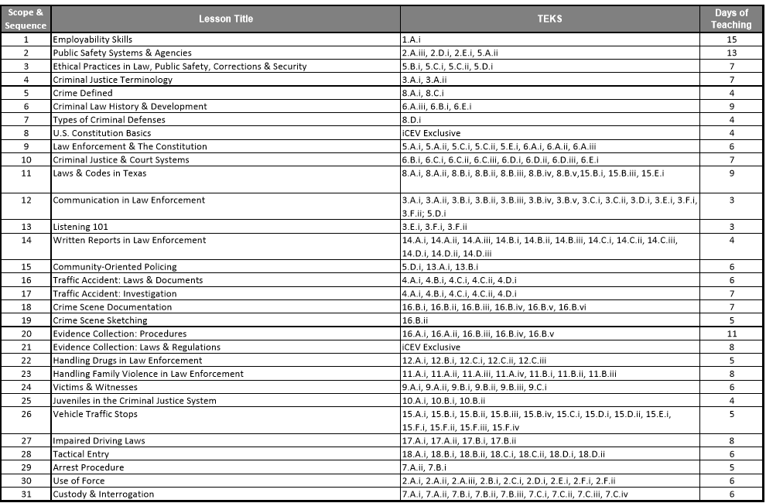
TEKS Alignment

Course Syllabus Acknowledgement Form

Rivera Early College High School
6955 FM 802
Brownsville, TX 78521
(956) 698-1842

I am here to serve the educational needs of your child. I am looking forward to having your child in my class and to having a great year. If you should feel the need to speak with me, please feel free to call the phone number above and leave a message. I will return your call as soon as possible. My conference period is from 12:05 pm to 12:50 pm.

___________________________
Mrs. Anna B. Gaucin

I have received a copy of the Law Enforcement I course syllabus and classroom rules for Mrs. Anna B. Gaucin’s classroom.

___________________________________________ ________________
Student’s Printed Name Date

___________________________________________ ________________
Student’s Signature Date

___________________________________________ ________________
Parent/Guardian Signature Date

Parent(s) e-mail:_____________________________________________________

